YPWD WEST WORKSHOPS 3rd January – 10th February 2023

Day | Time | Dates | Workshop | Venue | Description
Monday | 2-4pm | 9th Jan – 6th Feb | Snooker and Pool | Crucible Sports Club  6 Richfield Avenue  Reading RG1 8EQ | Ever fancied yourself as the next Steve Davis or Alex Higgins. Then join us at the tables to pot some balls.  Free on-site parking and refreshments by YPWD contributions.
Tuesday | 10.15am-11.45am | 3rd Jan – 7th Feb | Harmony Choir | South Street Arts Centre  South Street  Reading RG1 4QU | Join Brie and the team as we prepare for our Christmas Concert. Sing some well-loved songs from through the ages.  Song choices are made by the choir and are well known to all.  On street parking available, payment required at meter. Refreshments provided.
Tuesday | 2pm-4pm | 3rd Jan – 7th Feb | Reminiscence | School Green Centre  School Green Shinfield RG2 9EH | Using the items from our memory boxes, we will be chatting over our memories from earlier years in this relaxed environment.  On-site parking available, refreshments provided.
Wednesday | 10am - 12pm | 4th Jan – 8th Feb | Art Appreciation  James Rizzi  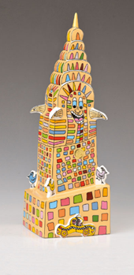 | Loddon Hall  Loddon Hall Road  Twyford  RG10 9JD | Join us to enter the world of James Rizzi as we turn our hand to drawing and sculptures of his famous laughing houses.  Free parking and refreshments.
Thursday | 10am - 12pm | 5th Jan – 9th Feb | Games Shows | Shaw House  Church Road  Newbury RG14 2DR | Have you ever wanted to be part of a game show on television? We can’t get you on the telly but we can offer fun and laughter as we have a go at some of the games together. You never know, you might win a prize or two along the way!  Free on-site parking. Refreshments provided.

